Problem Statement: You have been hired as a DevOps Engineer in XYZ software company. They want to implement CI/CD pipeline in their company. You have been asked to implement this lifecycle as fast as possible. As this is a product-based company, their product is available on this GitHub link. https://github.com/hshar/website.git

Following are the specifications of the continuous integration:

1. Git workflow has to be implemented

2. CodeBuild should automatically be triggered once a commit is made to master branch or develop branch. If a commit is made to master branch, build and publish a website on port 82. If a commit is made to develop a branch, just build the product, do not publish.

3. Create a pipeline for the above tasks

4. Create a container with Ubuntu and Apache installed in it and use that container to build the code and the code should be on /var/www/html.

Procedure: -

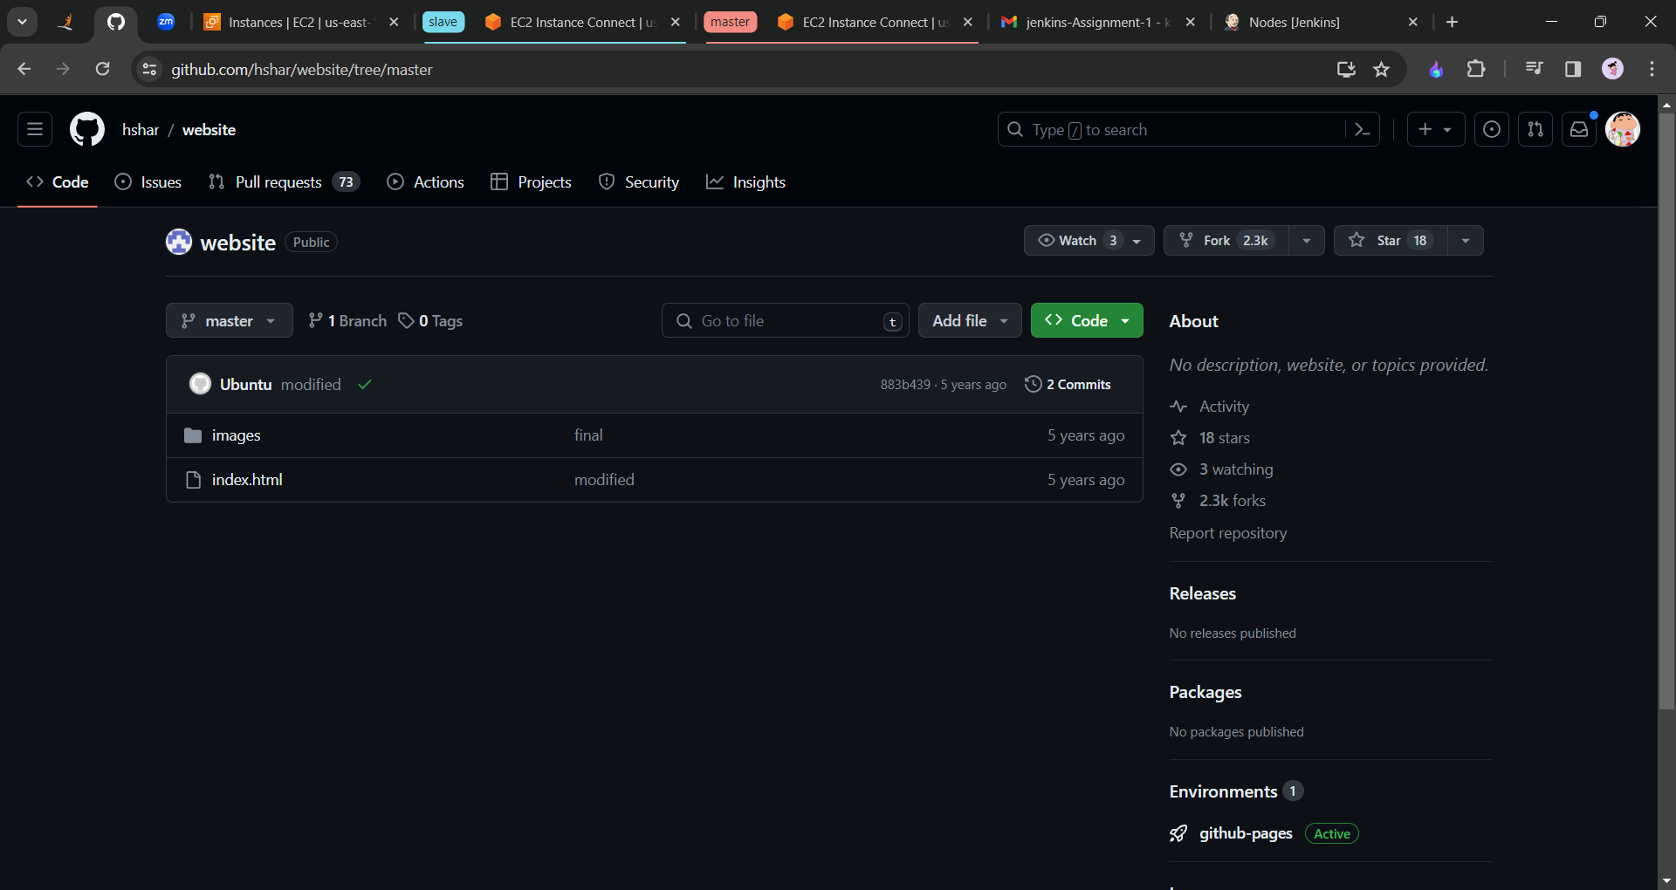

We need to fork the repository. Click on fork and create fork. After forking we will clone the repository. The command is git clone <https://github.com/Origamini/website.git>

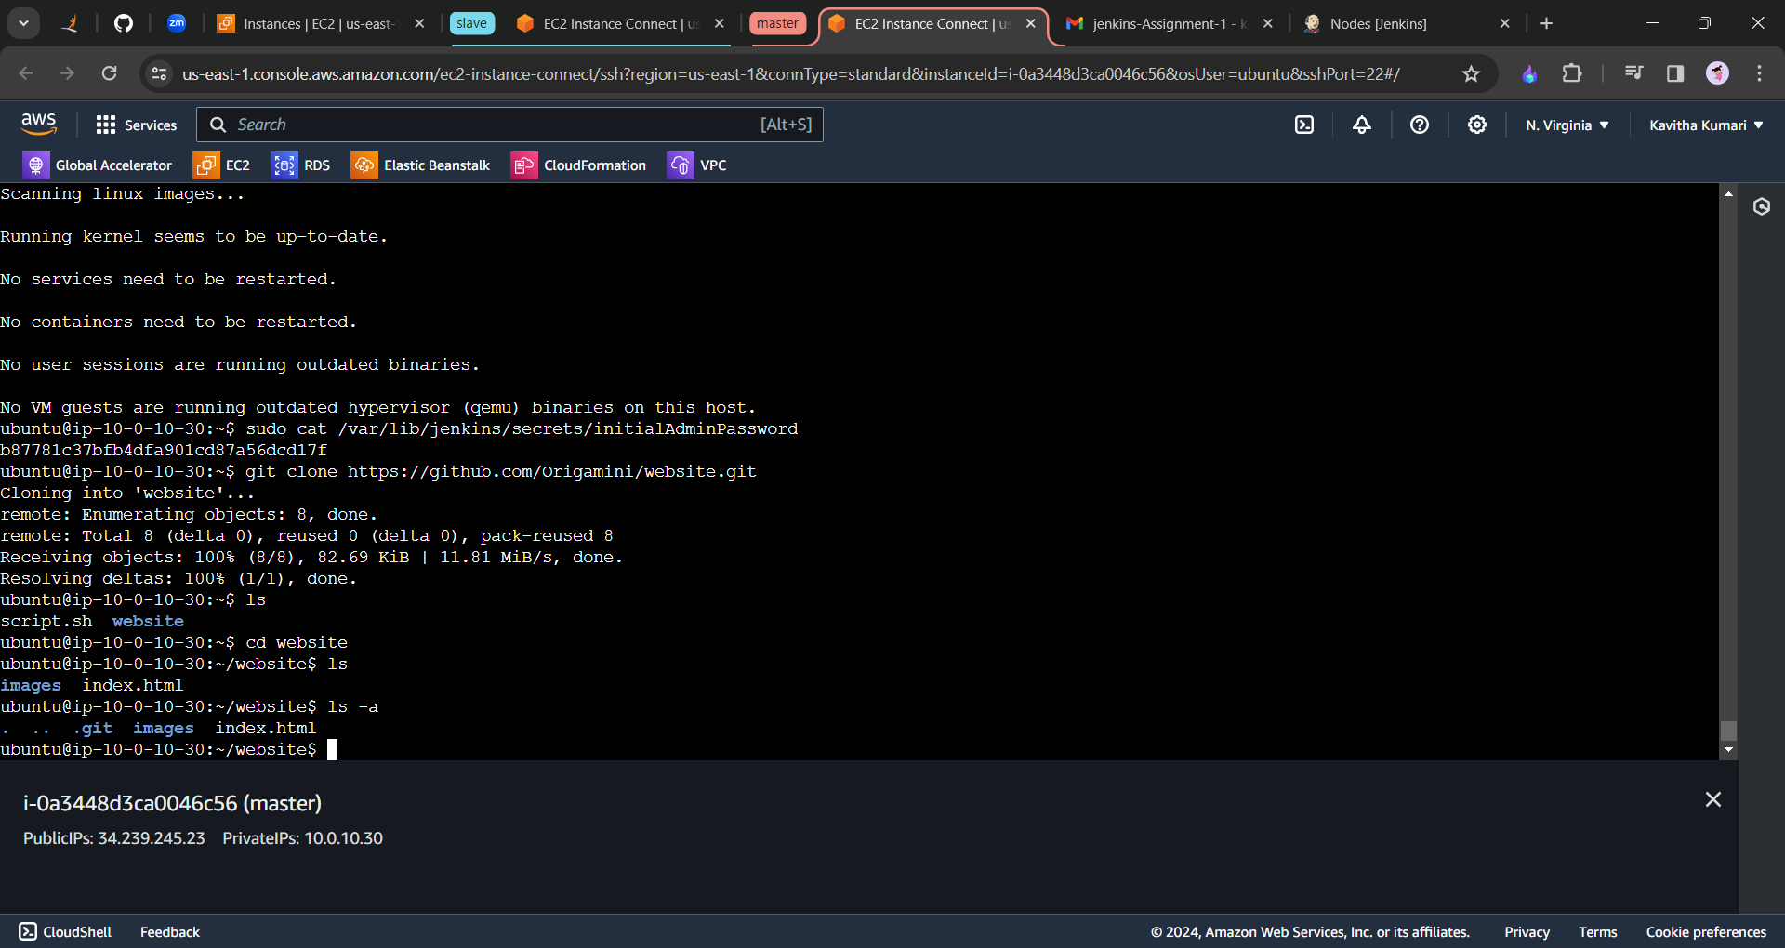

Now we will create the Dockerfile. With the command sudo nano Dockerfile

**FROM** ubuntu  
RUN apt-get update  
RUN apt-get install apache2 -y  
ADD . /var/www/html  
ENTRYPOINT apachectl -D FOREGROUND

Write this command in the Dockerfile. And save and exit file.

Now we have to stage the file and commit the file and create the new branch called Develop and also push all the changes to the master branch.

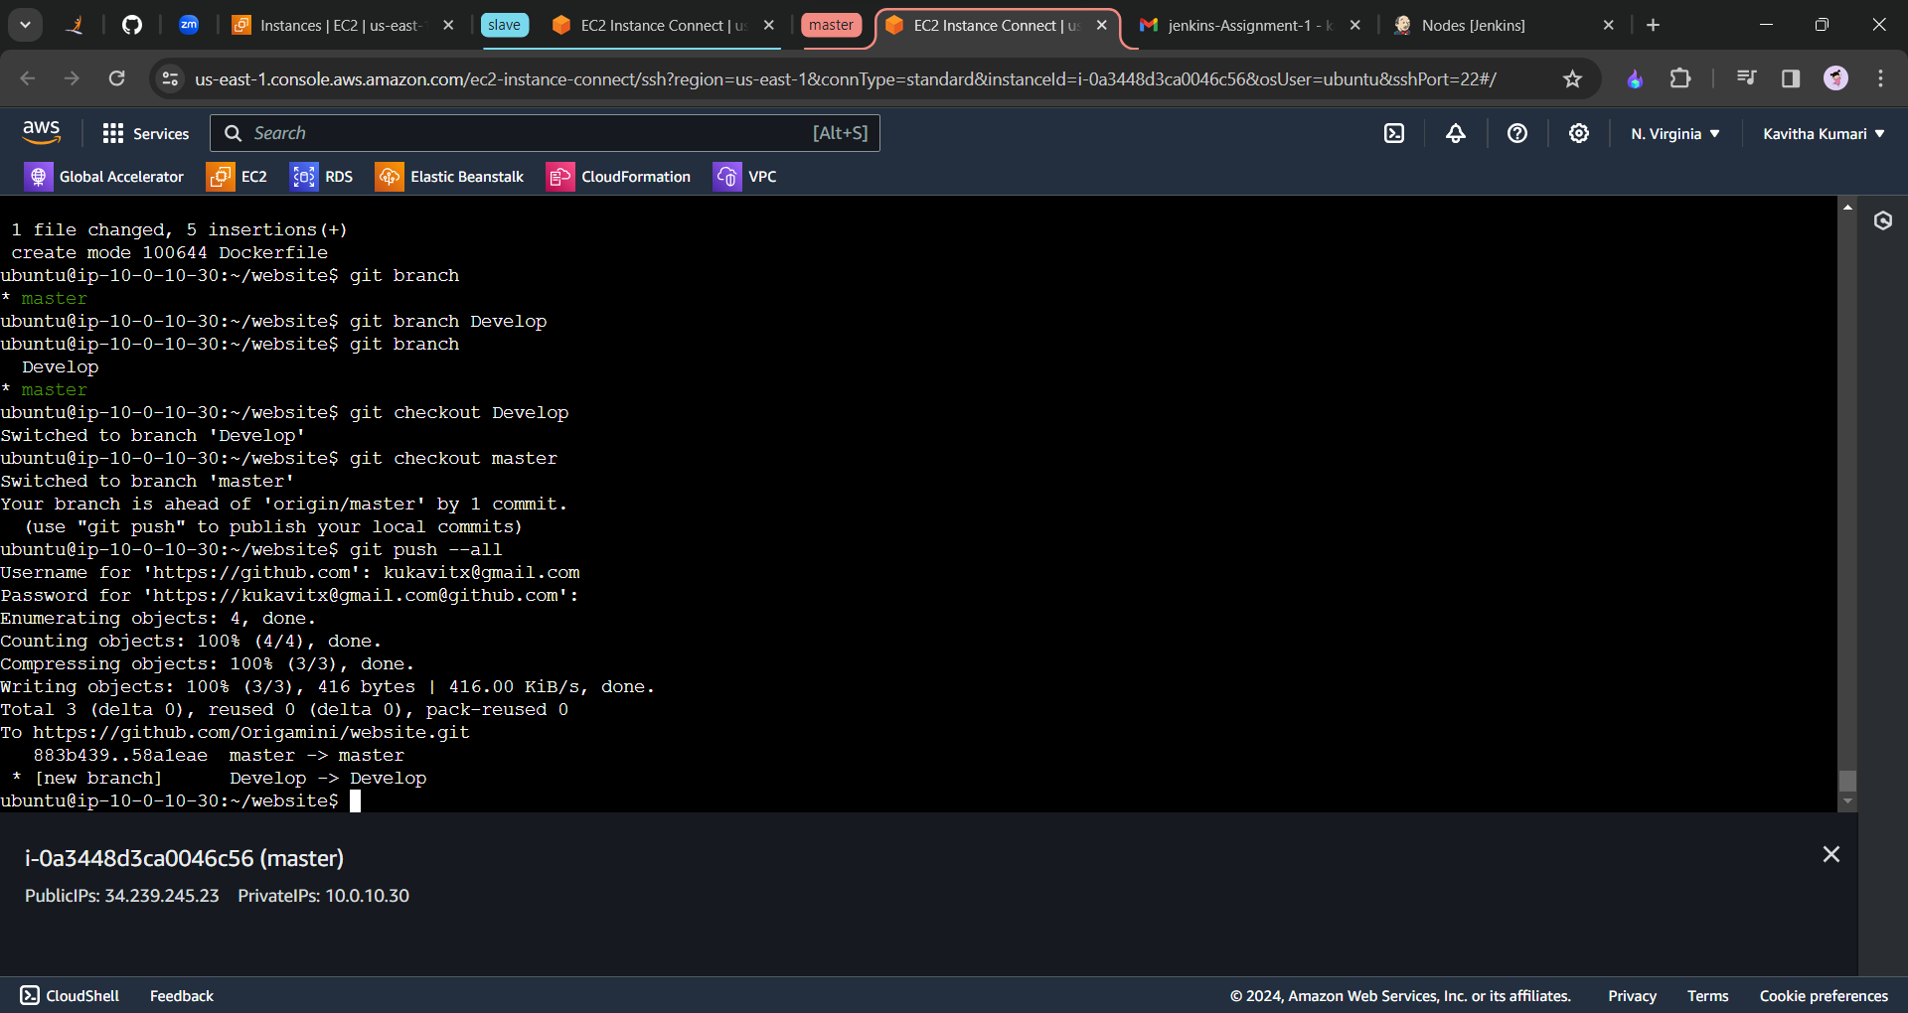

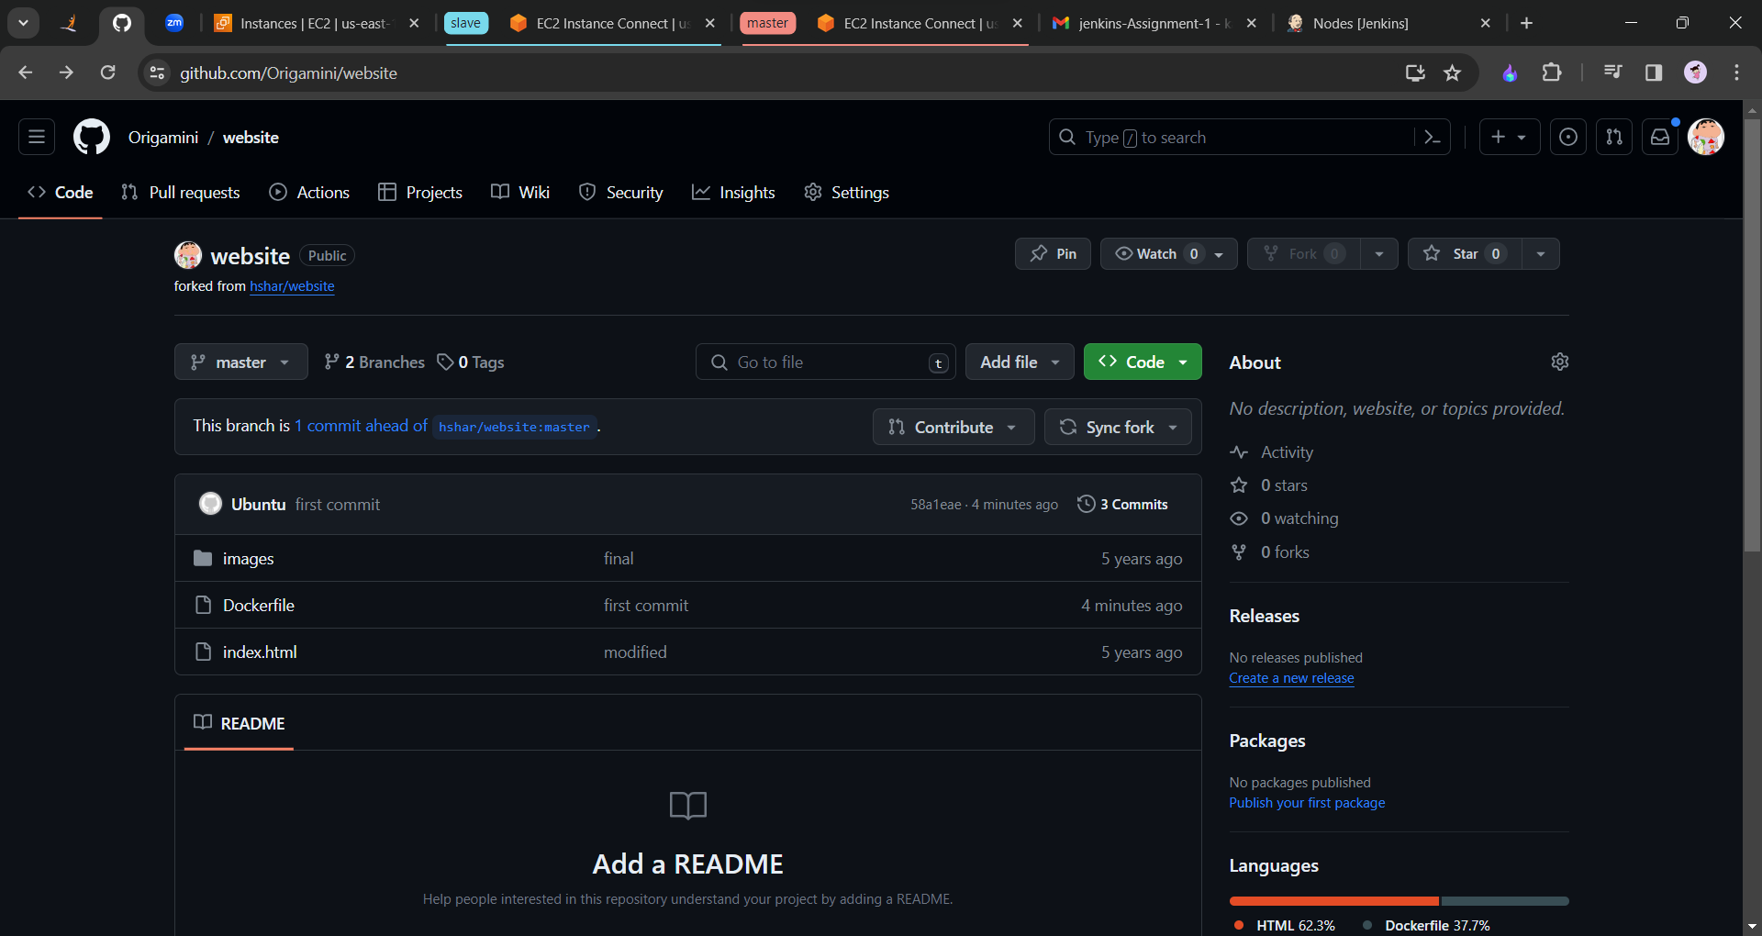

Therefore the new file “Dockerfile” has been added to the github.

Now let us install the Docker container in the Slave machine, “sudo apt install docker.io “

Now we have to create 2 job cases. For Develop branch it will be only triggered and for the master branch we need to publish it on the port number 80.

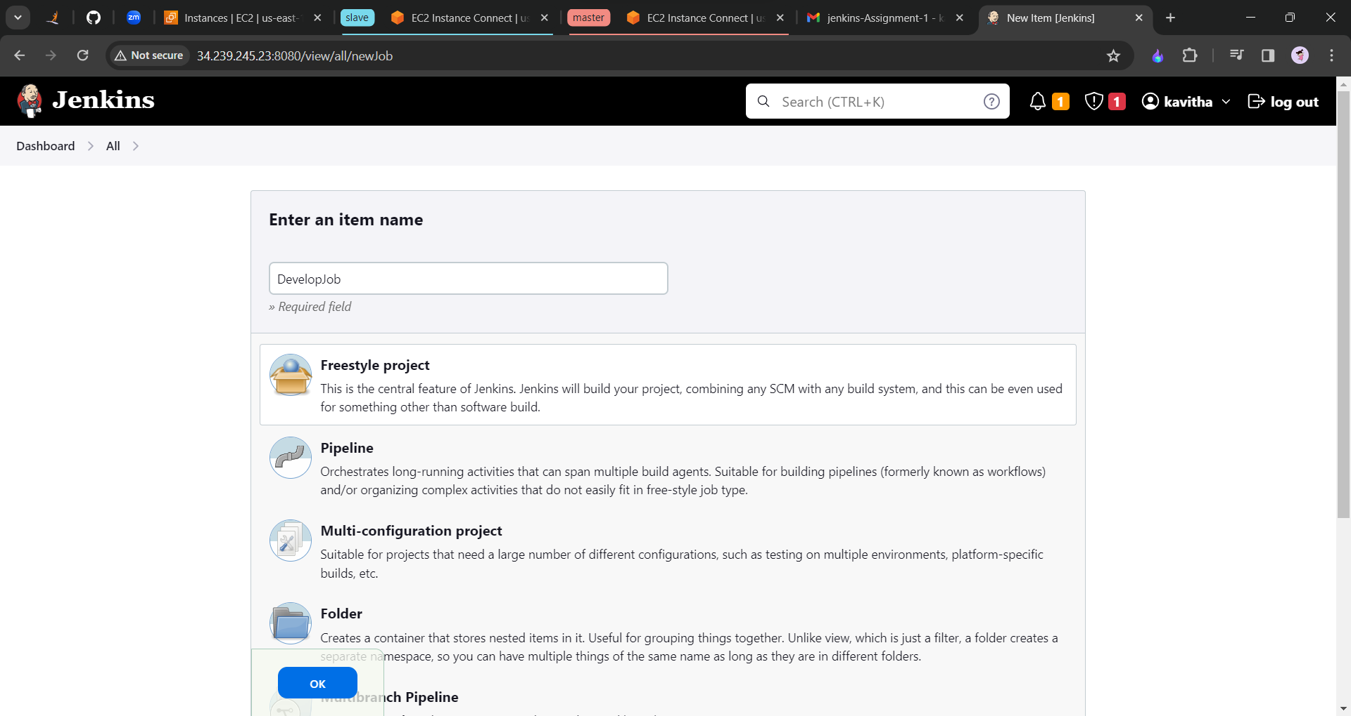

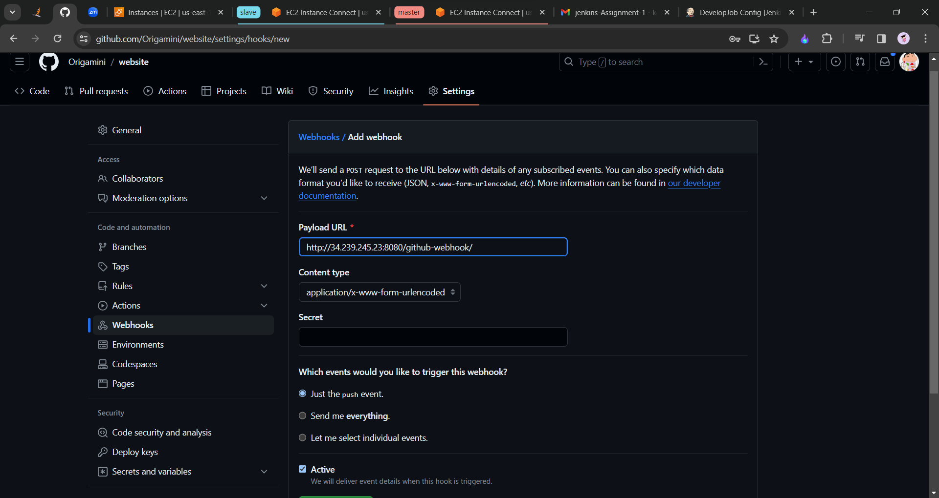

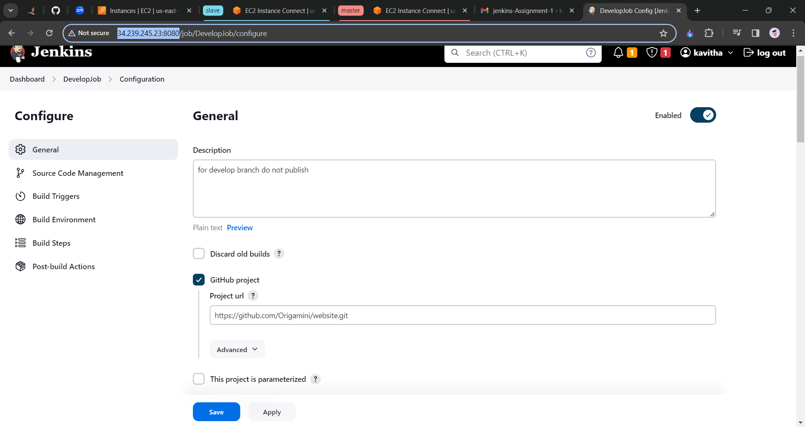

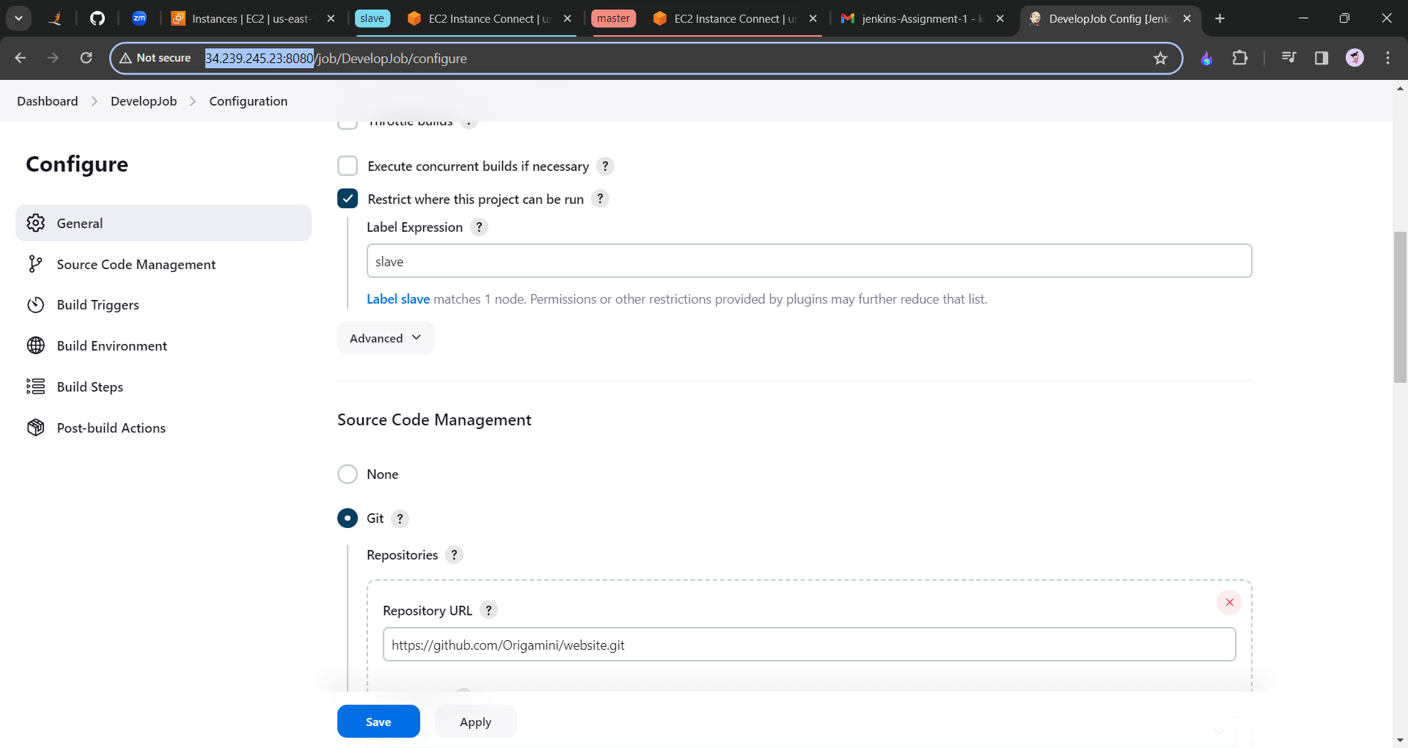

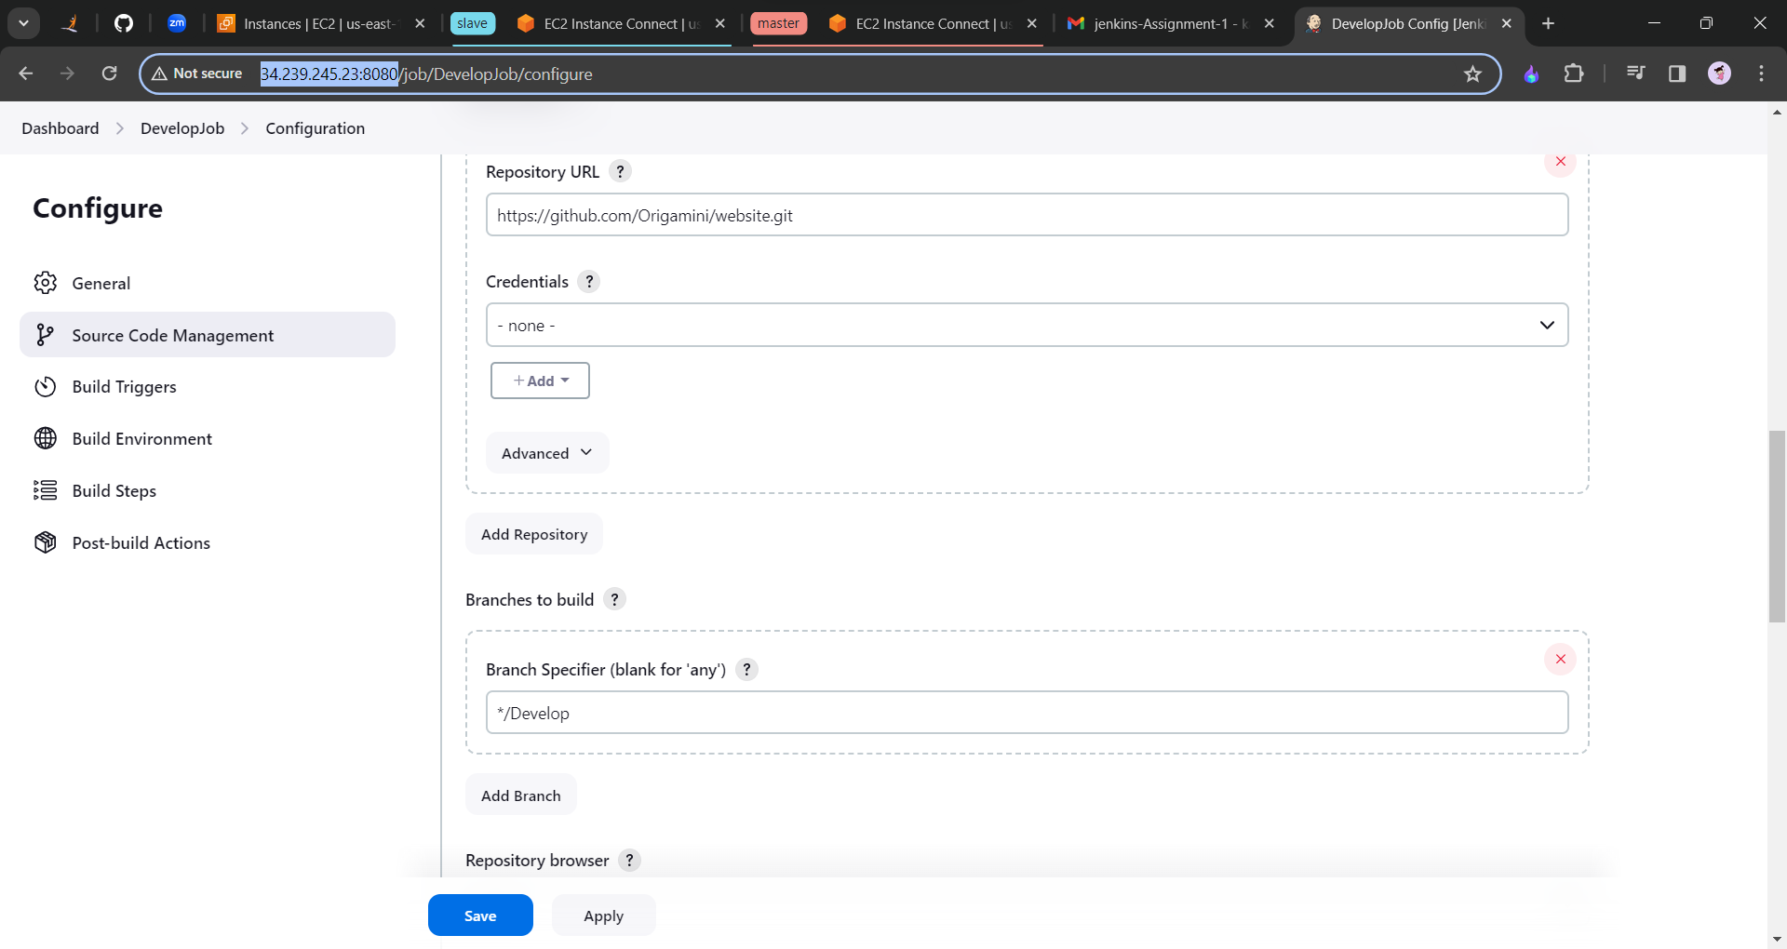

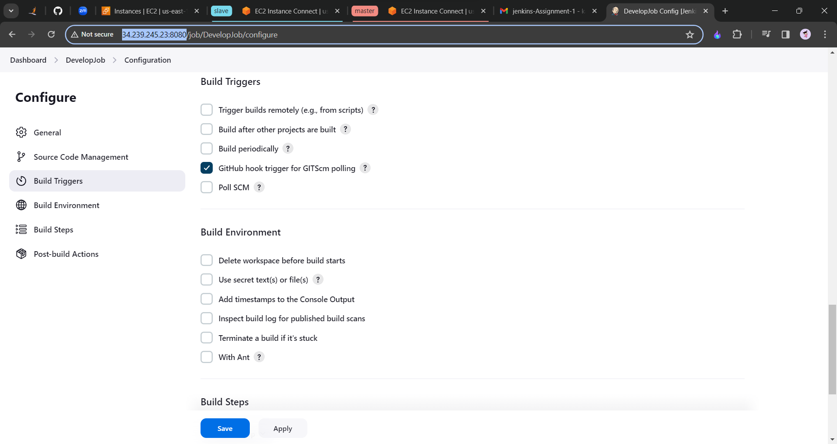

Click on save and apply. And build now.

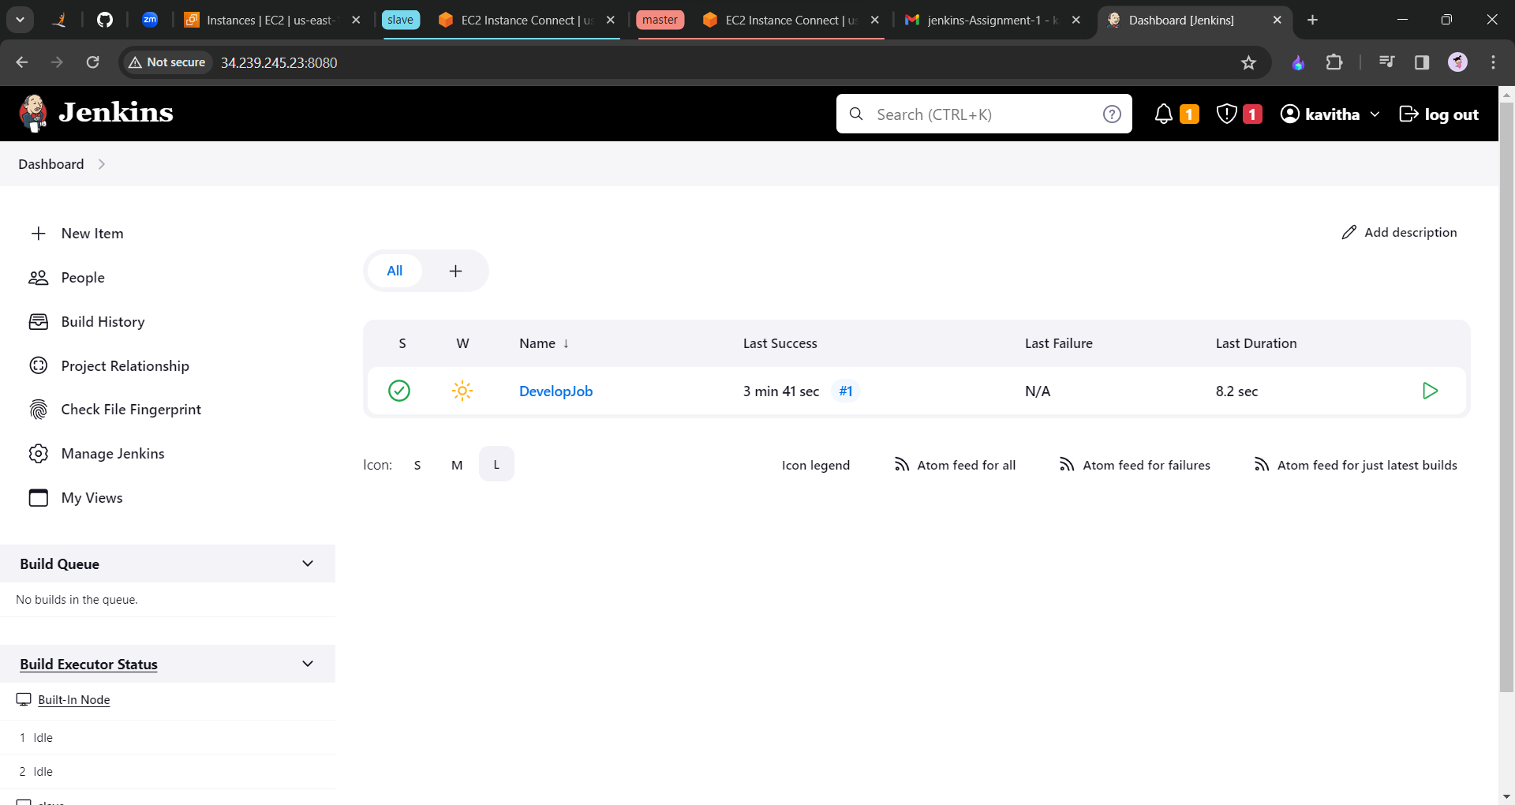

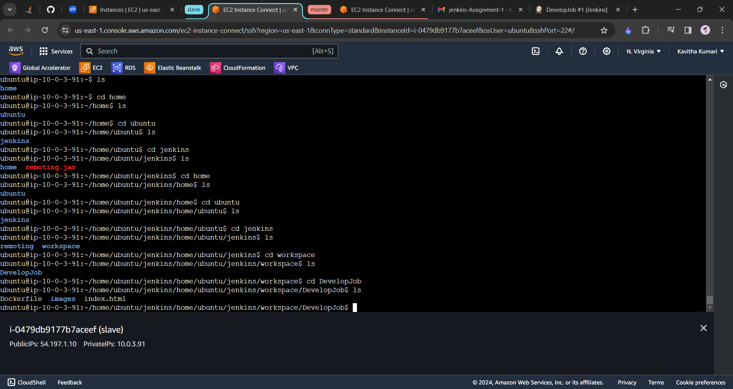

Now we will create one more job for our master branch which will ensure that the changes are visible on the port number 82.

Click on new item and create a job as follows.

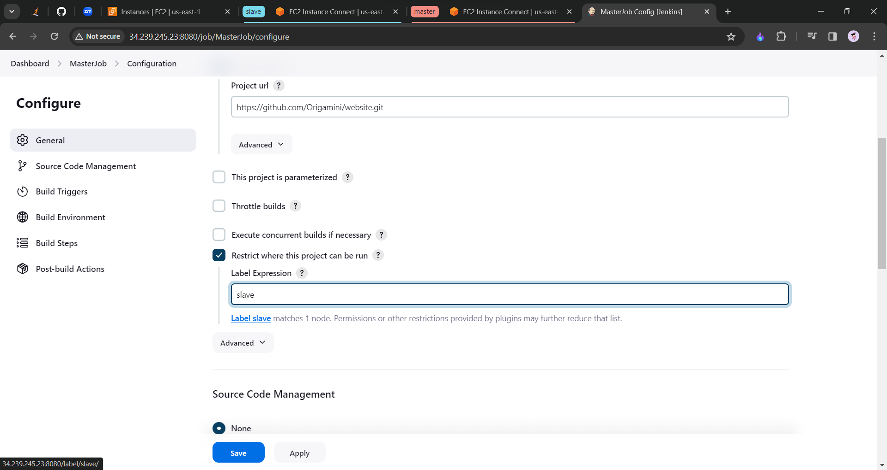

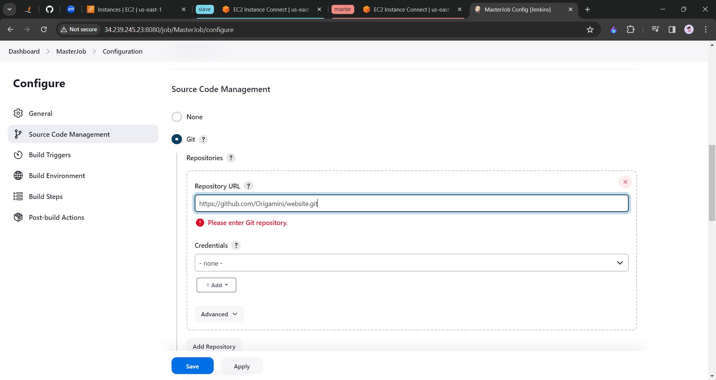

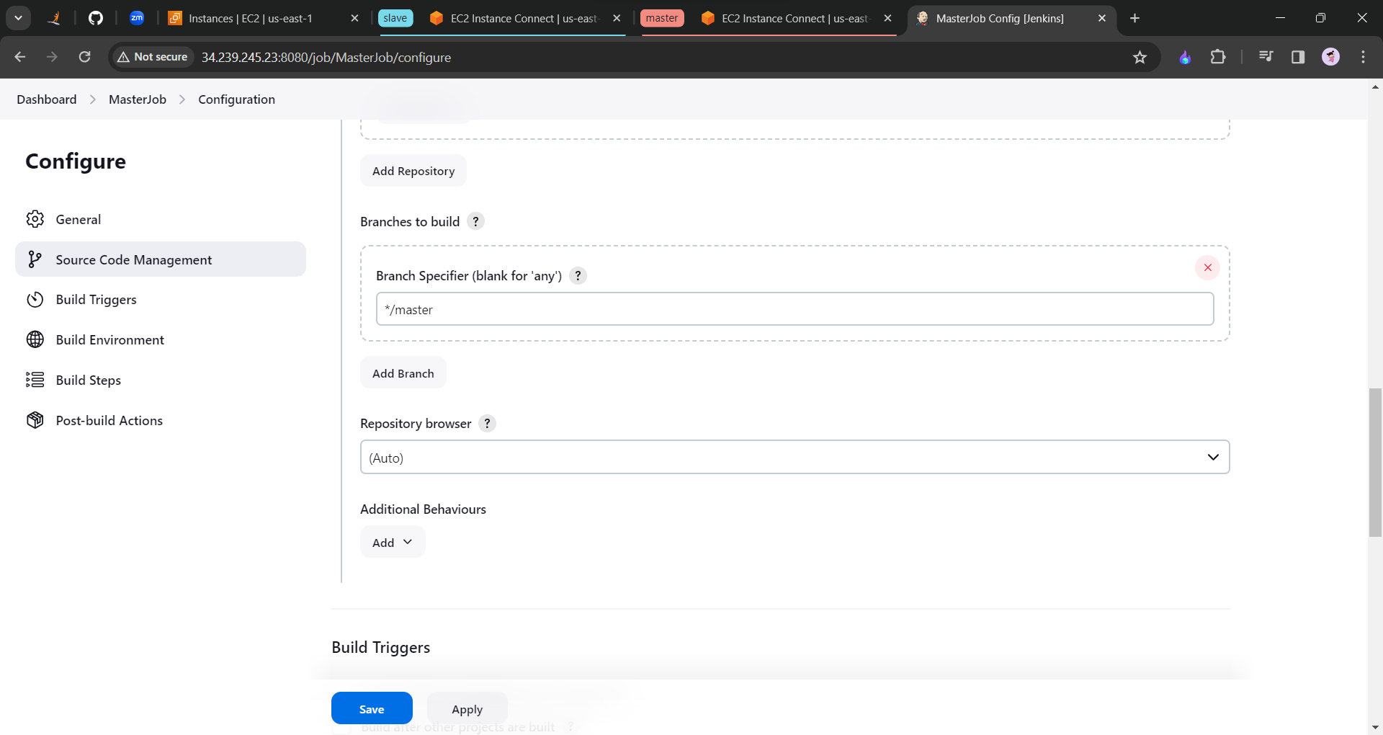

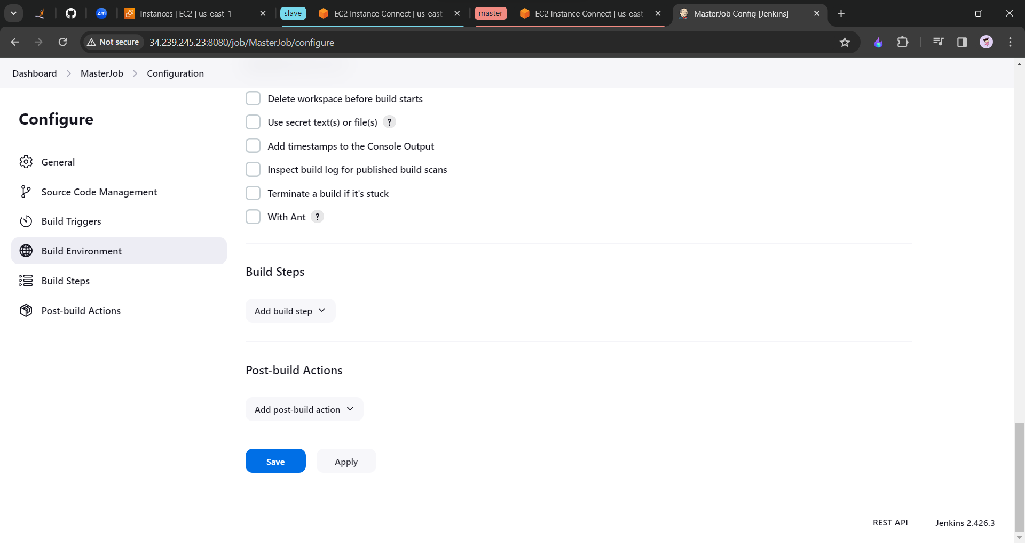

Click on save and apply.

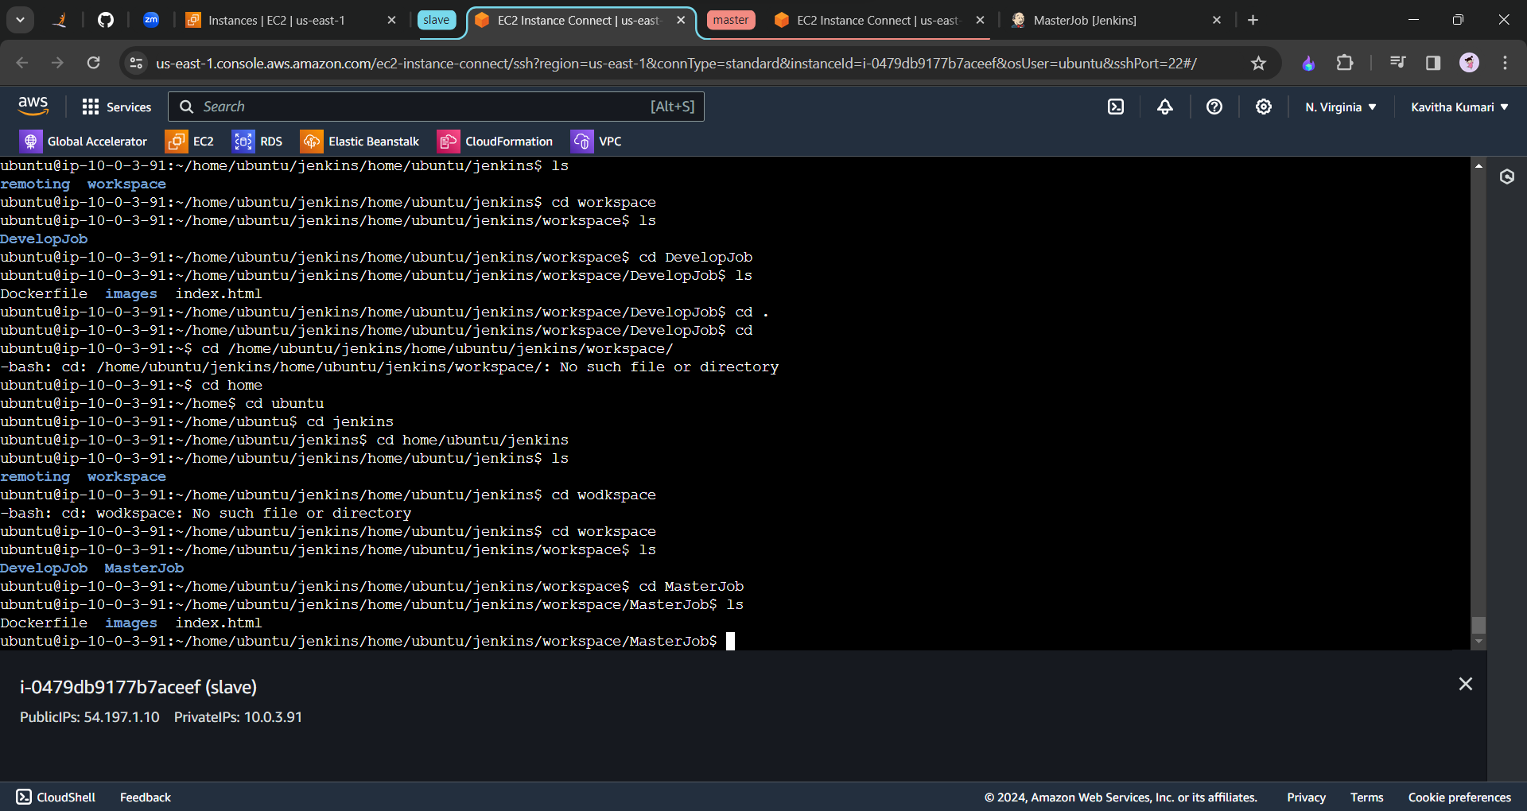

We need to check whether we have docker with the command which docker

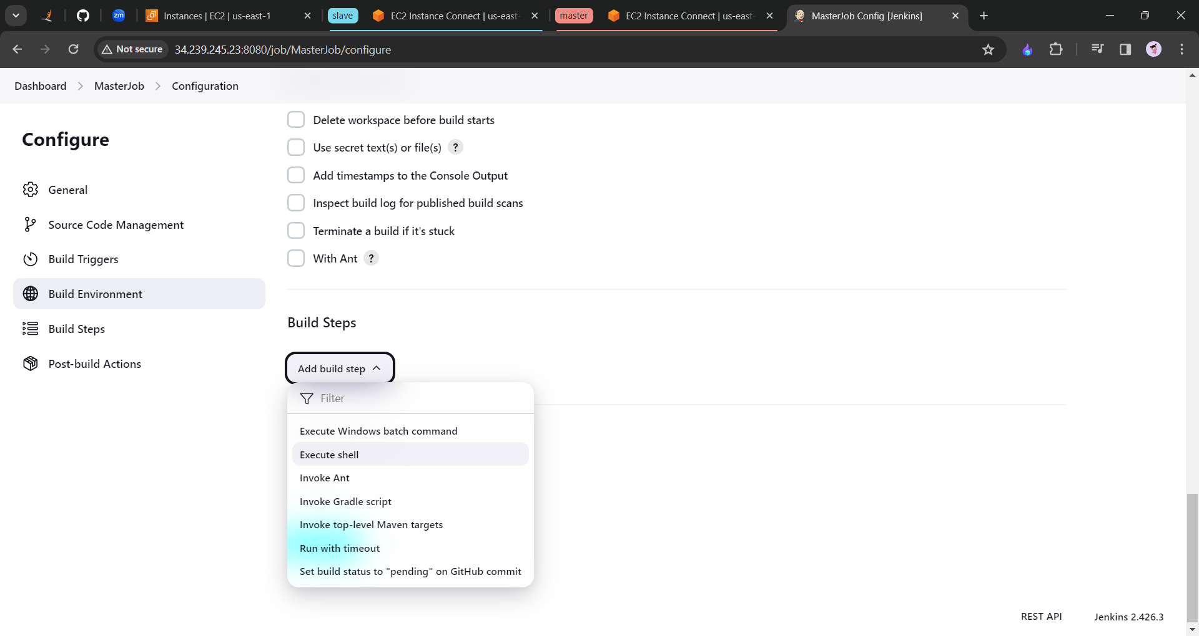

Click on execute shell and run the following command into the shell.

sudo docker rm -f $(sudo docker ps -a -q) //removes the previously running docker on port 82.

sudo docker build . -t masterapp

sudo docker run -itd --name websiteContainer -p 82:80 masterapp

click on save and apply and build now.

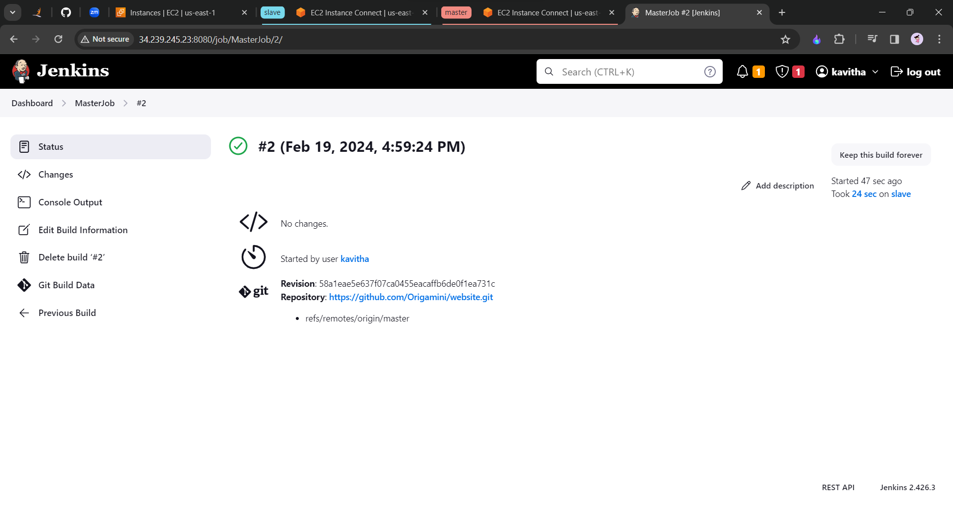

Now copy the IP address of the slave machine and check the port 82.

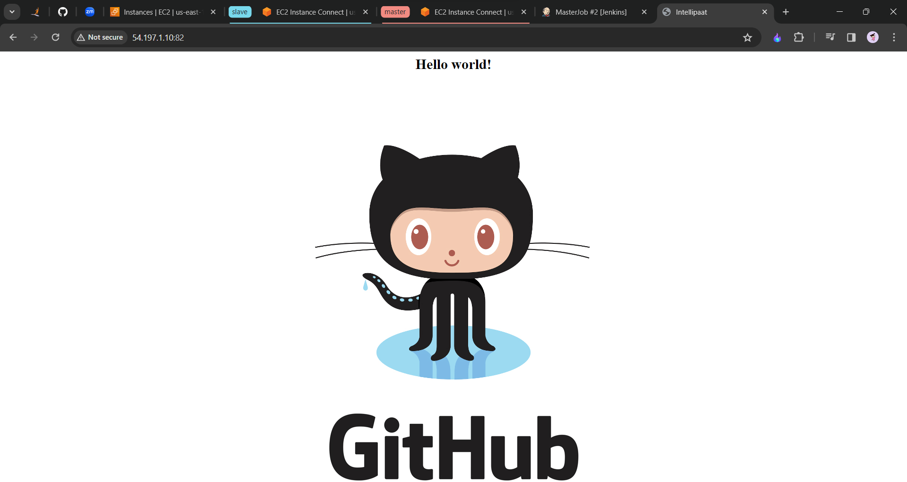

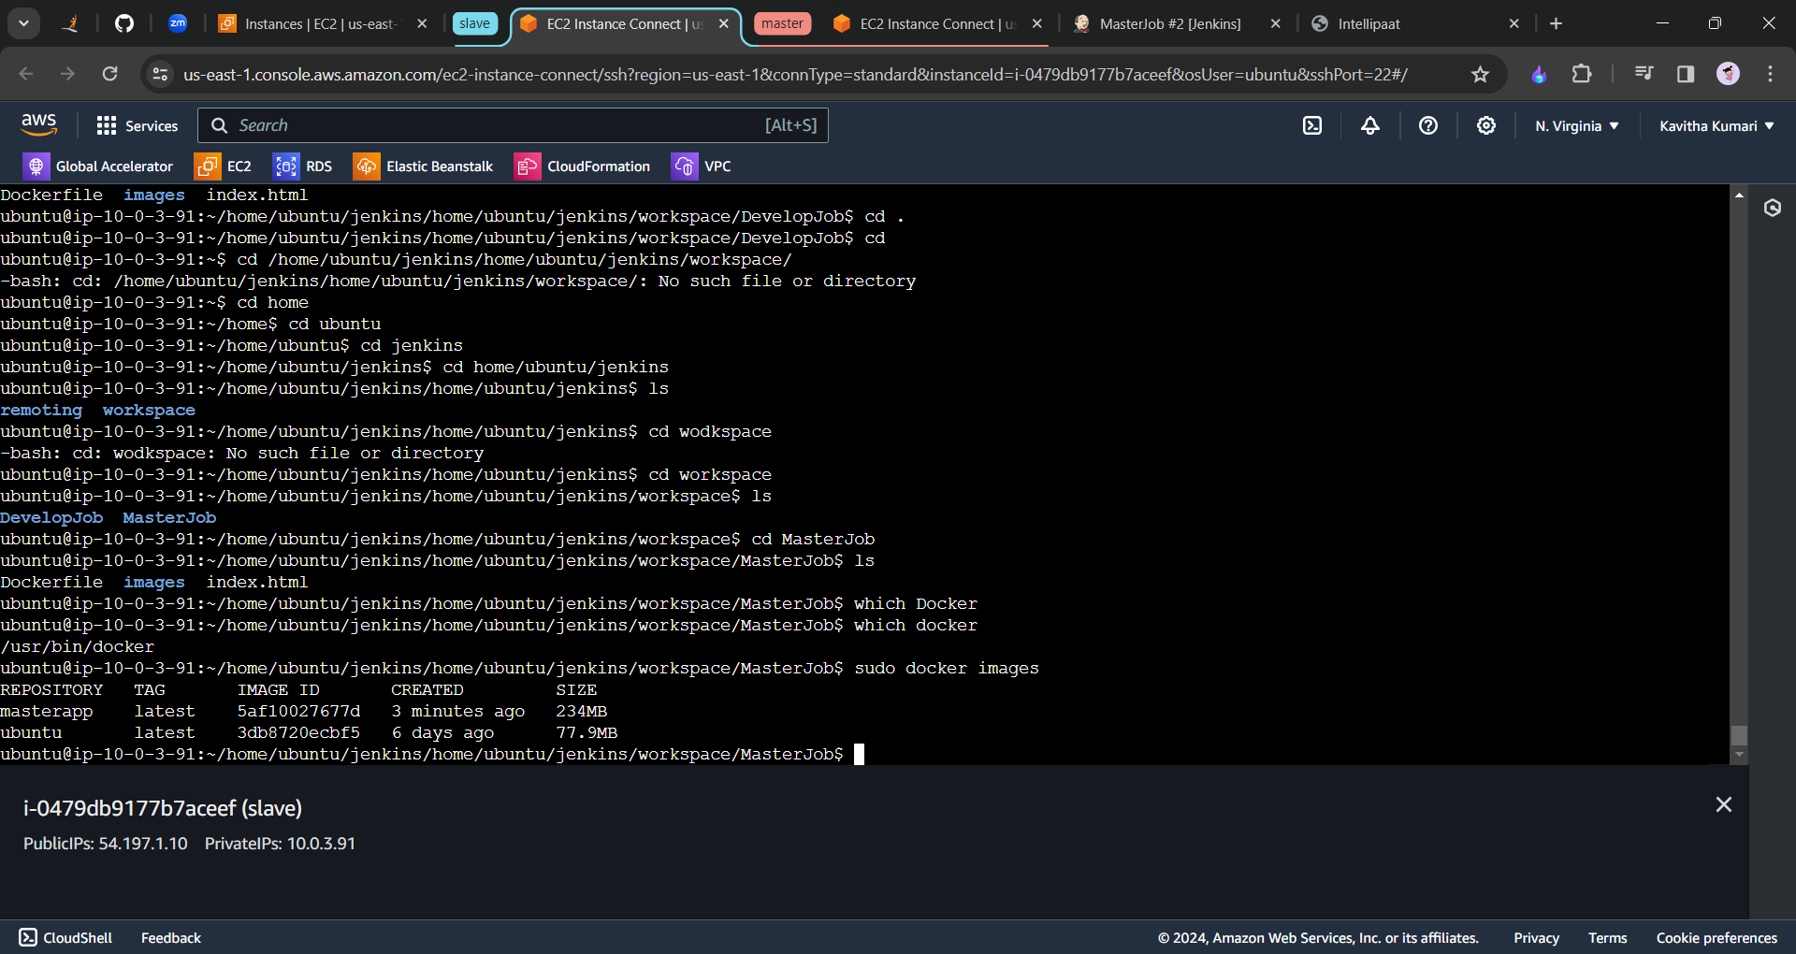

Let us try to make the changes in the master branch.

Job automatically started running.

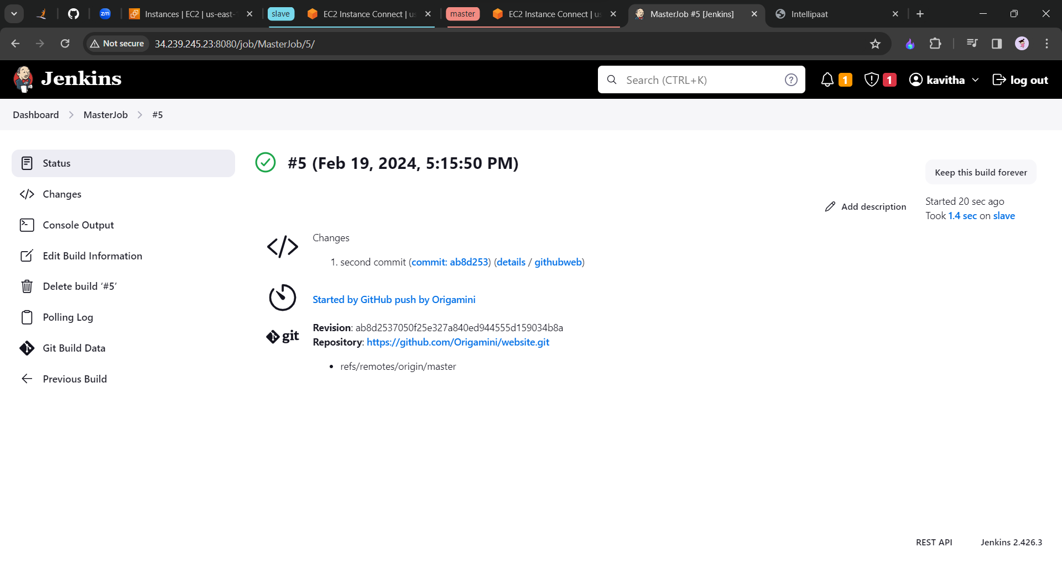

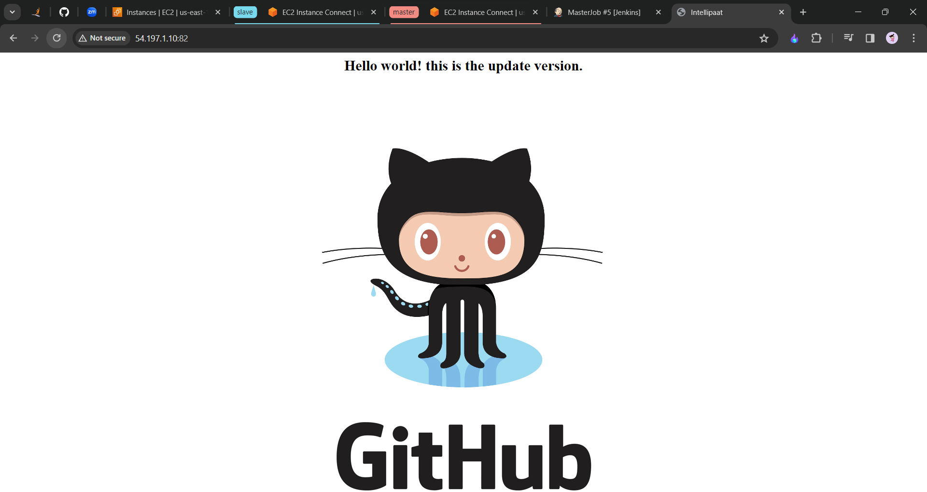

Also the file also updated with the content which I have gave.